PAPER TITLE [12 PT TIMES NEW ROMAN, BOLD, CAPITAL LETTERS]

Presenting author¹, second author², third author³, etc
[Times New Roman 12 pt, bold]

¹Department of Biomedical Engineering, AIBBC University, Nairobi, Kenya

²Department of Biotechnology, AIBBC 2024 University, Lagos, Nigeria

³Department of Infectious Diseases, AIBBC 2026 University, Addis Ababa, Ethiopia

[Department, Institution name, City, Country [Times New Roman 12 pt]

FORMATING GUIDELINES (Please follow strictly!)
- Please make sure that the title of your abstract is center aligned, capitalized, and written in bold font (Times New Romans, size 12pts).
- Leave an empty line after the title, then list all authors in order, with the presenting author underlined. Author names should also be centered, and should appear in the following order: First Name, Middle Name, Surname Name.
- Leave a blank line after the authors and then list the affiliations of all the authors. Name of your Department, Name of your Institution, Name of the City and the Country in which your institution is located should be given. The affiliation(s) should be followed by an empty line. The main BODYof the abstract should follow accordingly.
- The abstract should be written in less than TWO pages. Figures and references can be inserted or gathered on the second page. The paper size should be A4 (29.7 x 21.0 cm), with margins of 2.5 cm on all four sides.
- The entire abstract should be written with Times New Roman 12 pt.
- Importantly, the body of your abstract should contain the following sections.

1. ABSTRACT
This section should contain a short and concise summary of your study, written in a few lines.

2. INTRODUCTION
Give a brief background introduction of your work, clearly stating the objective of your study.

3. RESULTS AND DISCUSSIONS
In this section, please list your major results and discuss them concisely. Include at least ONE figure to support your study. Please note that abstracts outlining study proposals and/or preliminary studies with no data will not be accepted for this conference.

4. CONCLUSION

SUPPORTING FIGURES
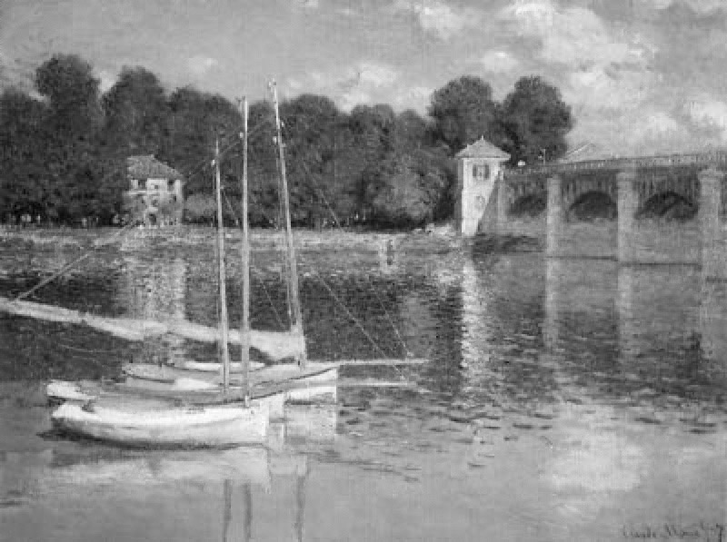
Figure 1: Spectral content of diffracted light from a programmed grating for single (upper) and double (lower) band pass filters. The dashed lines are the simulated spectra while the solid lines are the measured spectra.
Figure 2: Reflections on corrugated liquid/gas interface, with obstacles, observed by Monet. Rendering with 300 dpi

ACKNOWLEDGEMENT

REFERENCES

CONTACT (Optional): Email address

